COM161 Problem Solving for Computing Practical Lab

Practical Lab 3 – Implementing Decision in Code
The tasks below are based on the lecture session Decision Structures. In several cases, you are directed to sample program code, available on Blackboard Ultra. In each case, you should download and save a copy of the code to your own folder before editing.

- A copy of the program test_average.py, which was used as a worked example in the lecture, is available on Blackboard.

- Modify the code so that it takes the average of four scores rather than three and congratulates the user if s/he gets a score of over 70.

- The code currently has several weaknesses. It only accepts integer input, and it may return the result to many decimal places. Modify the code to remove these two issues.

- Modify the code so that it congratulates the user for a high score and prints a stern warning if the score is too low.

- Write a program which follows the logic of Figure 3.5 of the slides (under section - The if-else Statement). It should ask the user to enter the temperature, and then print one of the two statements depending on the input.

- A copy of the program grader.py, which was used as an example in Figure 3.15 of the slides (under section - The if-elif-else Statement), is available on Blackboard.

Modify the code to ask the user to enter their marks (out of 100) on three pieces of coursework for a module. The final mark for the module is the average of the three coursework marks. The program should ask for the three marks and display the overall mark and the grade.

- Assume the variables a=2, b=4 and c=6. Which of the following statements are true?
a==4 or b>2
6<=c and a>3
1!=b and c!=3
a>=-1 or a<=b
not(a>b)
Check your answers using the Python interpreter in interactive mode.

- A hardware company sells nails at 10p each. It charges £2 for postage and packing irrespective of how many nails are ordered, but it also gives discount for bulk purchase as follows:
Number of nails bought | Discount
1-50 | 0%
51-100 | 10%
100-200 | 20%
201 or more | 25%

Write a program that asks the user how many nails they want to buy. The program should then display the percentage discount that will be applied, the cost order before postage and packing, and the total bill including postage and packing.

- Mark Donnelly has written a short piece of Python code. Badly. Very badly. It is supposed to test eligibility for a bank loan. It doesn’t. It can be found on Blackboard (bugged_bank_loan.py). In a rather abrupt email, Simon Fraser has contacted him saying that he has discovered 9 errors in the code and if they are ‘fixed pretty flipping quick’ he’ll be ‘demoted to office tea-maker and pencil sharpener by the end of the week’. He needs help. Can you debug the code for him?

- By sketching up (on paper or in Word) an appropriate truth table show that not (P or Q) is logically equivalent to (not P) and (not Q).

- What is the truth value of the proposition (not(X and Y) or Z) and (not (Q and P))? Where:
P = Ballymena is in County Down,
Q = Light from the sun reaches earth in less than 10 minutes,
X = Ulster University has a campus in Belfast,
Y = Stephen Hawking is dead,
Z = It is the year 2025 .
Check your answer using Python.

- The short program square.py, available on Blackboard, draws a square of side length 100. Modify this code to allow the user to be asked to specify:

- the side length
- the pen thickness
- the animation speed
- the pen colour
Hint: you may want to edit the code gradually, adding these features one at a time.

As a follow up challenge, can you modify the code to draw a hexagon instead?

- Is it a leap year? Write a program which asks the user to enter the year and then displays whether the entered year is a leap year or not. The following criteria should be used:

- If a year is divisible by 100 and is also divisible by 400 it is a leap year.
- If a year is not divisible by 100, then it is a leap year if it is divisible by 4.
Hint: use the % operator.

- Chinese years are assigned animals on a 12-year cycle. A full cycle is given below.
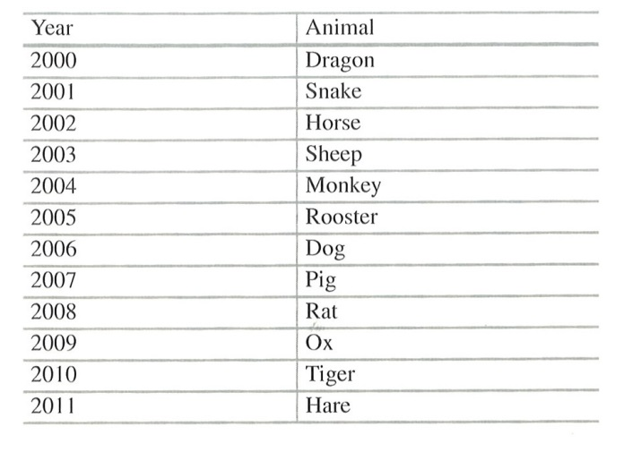
Write a program that reads a year from the user and displays the animal associated with that year. Your program should work for any year greater than zero, not just the ones listed in the table.

AI in Focus

Student Discount Checker
Problem: A local cinema offers student tickets at a reduced price. Together with AI, write a program that asks the user if they are a student (yes or no) and displays:
- "Student Discount Available" if they are a student
- "Standard Ticket Price" otherwise.

Note: if interested, you may add to the complexity of this problem.

Your tasks:
- Using the ‘Ask AI’ feature in Chrome or Edge draft pseudocode for this problem.
- Identify one assumption AI has made.
- If required, improve the prompt.
- Attempt to convert this into Python code yourself.
- Ask AI to appraise your code and help refine / improve (two-step process!)
- Finally, ask the AI to provide you with test cases that you can manually enter into your running program.

